

**KHOA CÔNG NGHỆ THÔNG TIN**

**TRƯỜNG ĐẠI HỌC BÁCH KHOA – ĐẠI HỌC ĐÀ NẴNG**

**PBL3 PROJECT REPORT**

**Report 1 – Project Introduction**

– DaNang, January 2025 –

**Table of Contents**

I. Record of Changes 3

II. Project Introduction 4

1. Overview 4

1.1 Project Information 4

1.2 Project Team 4

2. Product Background 4

3. Existing Systems 5

3.1 Amazon, Shopee, Lazada 5

3.2 Smaller Platforms (Thegioididong …) 6

4. Business Opportunity 7

5. Software Product Vision 7

6. Project Scope & Limitations 8

6.1 Major Features 8

6.2 Limitations & Exclusions 10

# I. Record of Changes

|  |  |  |  |
| --- | --- | --- | --- |
| **Date** | **A* M, D** | **In charge** | **Change Description** |
|  |  |  |  |
|  |  |  |  |
|  |  |  |  |
|  |  |  |  |
|  |  |  |  |
|  |  |  |  |
|  |  |  |  |
|  |  |  |  |
|  |  |  |  |
|  |  |  |  |
|  |  |  |  |
|  |  |  |  |
|  |  |  |  |

*A - Added M - Modified D - Deleted

# II. Project Introduction

## 1. Overview

### 1.1 Project Information

* Project name: Sales Management Software
* Project code: SMS
* Group name: 23.Nh12A_Team
* Software type: Web

### 1.2 Project Team

|  |  |  |  |
| --- | --- | --- | --- |
| **Full Name** | **Role** | **Email** | **Mobile** |
| Vo Duc Hoang | Lecturer | hoangvd.it@dut.udn.vn | 0906477283 |
| Ngo Van Loc | Member | 102230197@sv1.dut.udn.vn | 0359757054 |
| Nguyen Hieu | Member | 102230185@sv1.dut.udn.vn | 0327334805 |
| Ha Duc Kien | Member | 102230194@sv1.dut.udn.vn | 0387717425 |
| Huynh Thao Nhi | Member | 102230258@sv1.dut.udn.vn | 0796852408 |

## 2. Product Background

* Current situation

Nowadays, retail stores, supermarkets, and shopping centers need an effective sales management system to track products, process orders, and manage revenue. However, most stores still use manual methods or simple software, making it difficult to manage goods and payments. This not only reduces work efficiency but also negatively affects the shopping experience for customers, lowering the quality of sales service.

* Alternative Solutions and Their Limitations

Another option is to manually manage or record sales information in notebooks. However, this method is often time-consuming, prone to errors, and does not meet the needs of modern management. As a result, many stores today choose to use sales management software to optimize their operations, saving time and effort. However, not everyone knows how to use the software effectively or how to choose the right one for their needs. With the rapid development of AI technology, many software solutions have become smarter, supporting the automation of sales processes. Nevertheless, this also increases the risk of using unreliable software, which may lead to data loss or incorrect information, causing unwanted consequences for businesses.

* Proposed Solution

To address these challenges, we aim to create a modern sales management software system that serves not only store owners but also supports staff and provides the best experience for customers. This system will help optimize product management, track orders, and handle payments quickly and efficiently. The sales process will no longer be complicated or time-consuming as with manual methods. Additionally, the system ensures secure data storage, accurate transaction information, and easy revenue analysis, helping to improve business efficiency and increase customer satisfaction.

## 3. Existing Systems

### 3.1 Amazon, Shopee, Lazada

*3.1.1 Brief descriptions*

* *An e-commerce platform used for connecting buyers and sellers which providing shopping experience with some features such as online payments,recommended products… and the various kinds of products*

*3.1.2 The link:*

***Amazon:*** [*https://www.amazon.com*](https://www.amazon.com)

***Shopee:*** [*https://shopee.vn*](https://shopee.vn)

***Lazada:*** [*https://www.lazada.vn*](https://www.lazada.vn)

*3.1.3 The system actors*

* ***Administrator:*** *Manages system configurations, user accounts, and overall operations.*
* ***Seller:*** *Adds, updates, and manages products, orders, and customer interactions.*
* ***Buyer:*** *Searches, purchases, and reviews products.*
* ***Delivery Partner:*** *Manages shipping and tracking of products.*

*3.1.4 Features*

* *Registration and Login*
* *Searching and filtering product*
* *Personalized recommendations*
* *Cart and payment*
* *Real-time tracking*
* *Review and rating product*
* *Admin dashboard*

*3.1.5*

* *Pros:* 
  + *Interface: Professional, intuitive, user-friendly*
  + *Personalized*
  + *Convenient online payment features: Multiple online payment methods are supported, making transactions quick and secure*
  + *Product diversity: These platforms offer a wide range of products from various categories, catering to diverse consumer needs*
  + *Attractive promotional programs: Discount programs, deals, or flash sales attract users, offering opportunities for savings*
  + *Easy return policies: These platforms offer simple return and exchange policies, giving consumers peace of mind when shopping*
* *Cons:*
  + *Some UI with many features can make the page more and more complex*
  + *Uneven product quality: Although there is a wide variety of products, quality can vary, and consumers may encounter items that do not meet their expectations.*
  + *High shipping costs: For some orders, shipping fees can be quite high, especially for international shipments or heavy products.*
  + *Shipping times can be slow: Although there is a tracking feature, delivery times can be inconsistent, especially during large promotional events or peak seasons.*

### 3.2 Smaller Platforms (Thegioididong …)

*3.2.1 Brief descriptions*

* *An e-commerce platform used for connecting buyers and sellers which provides a shopping experience with some features such as online payments,recommended products… and the specified kind of products.*

*3.2.2 The link:*

***Thegioididong:***[*https://www.thegioididong.com/*](https://www.thegioididong.com/)

*3.2.3 The system actors*

* ***Administrator:*** *Manages system configurations, user accounts, and overall operations.*
* ***Employee:*** *Adds, updates, and manages products, orders, and customer interactions.*
* ***Buyer:*** *Searches, purchases, and reviews products.*

*3.2.4 Features*

* *Registration and Login*
* *Searching and filtering product*
* *Cart and payment: Users can add products to the cart and choose from various payment methods such as online payment, cash on delivery (COD), or e-wallets. These platforms support multiple secure and convenient payment methods, offering flexibility in transactions.*
* *Real-time tracking*
* *Review and rating product: Allows buyers to share their experiences and rate the quality of the product after use, helping other buyers gain a clearer understanding. These reviews and ratings enhance transparency and build trust with customers.*
* *Admin dashboard*

*3.2.5*

* *Pros:*
  + *Friendly interface*
  + *Diverse product range: Thegioididong provides a wide range of products from various categories, meeting the diverse shopping needs of consumers.*
  + *Safe and convenient payment options: The payment methods on these platforms are secure and fast, allowing buyers to complete transactions easily*
  + *Attractive promotional programs: These platforms frequently hold discount events and promotions, attracting consumers and providing savings opportunities.*
  + *Effective customer support: Customer support is available through multiple channels, including phone, email, and live chat, helping buyers resolve issues quickly.*
* *Cons*
  + Competition with larger platforms: Smaller platforms like Tiki and Thegioididong face intense competition from larger rivals such as Shopee and Lazada, which may reduce user traffic or consumer attention.
  + There is no diversity in sellers, as only one supplier provides the products, creating a monopoly on pricing, which may differ from other e-commerce platforms.
  + Difficulty in finding products: Although the platform offers a wide range of products, searching for items can sometimes be challenging due to a lack of detailed filters or clear categorization.

## 4. Business Opportunity

Many small business owners and shopkeepers face challenges in managing sales and inventory due to current systems being inflexible and disorganized, leading to errors in updates and wasting time on transactions. A smart sales management software will help shop owners track revenue, manage stock, and process orders quickly and accurately. This system will provide detailed reports on sales, best-selling products, and inventory levels, helping owners make better business decisions. Current software solutions do not fully integrate features like automatic inventory adjustments, customer data analysis, or online payment support, but the new software can address these issues. Using this software will not only increase work efficiency but also improve customer experience and open up more business opportunities in the digital age.

## 5. Software Product Vision

In a world where speed and efficiency are crucial, the Sales Management Application is designed as a comprehensive solution to help businesses streamline sales processes and enhance user experiences. This modern platform supports multiple roles, including Admin, Employee, and User, fostering a unified, flexible, and efficient business environment.

Admin: With centralized tools, Admins can monitor all business activities, manage user data, assign roles, oversee products, handle transactions, and track real-time revenue. These tools ensure smooth system operations and allow Admins to evaluate products based on sales performance and customer feedback.

Employee: Equipped with robust features, Employees can update product details, manage inventory, process orders, and assist Admins in day-to-day operations. This role reduces the administrative burden, improves efficiency, and ensures uninterrupted system performance.

User: Featuring a simple and intuitive interface, Users can effortlessly search for products, place orders, track their status, and receive timely assistance from staff. By shopping directly through the application, Users enjoy unparalleled convenience, transparency, and reliability.

The Sales Management Application not only enhances operational efficiency but also strengthens relationships among stakeholders. Unlike fragmented traditional systems, this platform integrates all essential features into one centralized hub, saving time, reducing costs, and increasing satisfaction across the board.

By implementing this application, businesses will witness transformative impacts:

Businesses will operate more efficiently, with seamless scalability, unrestricted by distance or resources.

Employees will shift their focus from repetitive tasks to supporting management and innovating processes, fostering creativity and continuous improvement.

Consumers will enjoy a modern, convenient, and transparent shopping experience, complete with detailed product information, real-time tracking, and responsive support.

Moreover, this application revolutionizes market approaches. With advanced data analytics, businesses can make informed decisions on pricing strategies and customer engagement. A unified and transparent transaction process builds trust, fostering long-term customer loyalty.

The Sales Management Application is a pivotal step toward realizing the vision of a sustainable, reliable, and comprehensive digital business platform—shaping a future where all stakeholders achieve unparalleled benefits.

## 6. Project Scope & Limitations

### 6.1 Major Features

|  |  |  |
| --- | --- | --- |
| **Major Feature** | | **Description** |
| **Product list** | | View the list of all products in the system |
| **Filter products** | | Filter the list of products in the system by name, genre or category |
| **Product detail** | | View specific details of a product, including name, category, price, supplier, etc. |
| **User** | Login | Login using an existing account |
| Sign up | Create a new account |
| Add product to cart | Add a product to the shopping cart |
| Remove product from cart | Remove a product from the shopping cart |
| Order | Place an order for the items in the cart |
| By cart order status | View the status of an order placed through the cart |
| Review order history | View a list of previous orders along with their details |
| Change password | Change the password of the account |
| **Employee** | Login up | Log in with the account provided by admin |
| Order management | Manage and process user orders |
| Product management | Update inventory information and view product list |
| **Admin** | Login | Log in using an exclusive account and password |
| Change password | Change the admin account’s password |
| Search user | Search for a specific user using their username or phone number to view their information |
| Search product | Search for a specific product by product code, product name or category to view product information |
| Product management | Add and remove products, modify product information and manage inventory |
| User management | Add and remove user, modify user information |
| Order management | Track all orders from all users |
| Statistic | Generate sales reports, view revenue trends, and analyze user purchase behavior |

FE-01: View and browse available products in the catalog.

FE-02: Manage shopping cart (add, update, and remove products).

FE-03:Create, view, modify, and delete personal account information.

FE-04:Track orders with statuses (Pending, Confirmed, Processing, Shipped).

FE-05: Reset or change password and send support requests.

FE-06: Administer account management, including creating, viewing, modifying, and deleting accounts.

FE-07:Manage product inventory, including adding, updating, and deleting products.

FE-08:Administer and track order statuses for all customers (Pending, Confirmed, Processing, Shipped).

FE-09:Generate and view reports on revenue and profit metrics.

FE-10: Provide customer support for order and account inquiries.

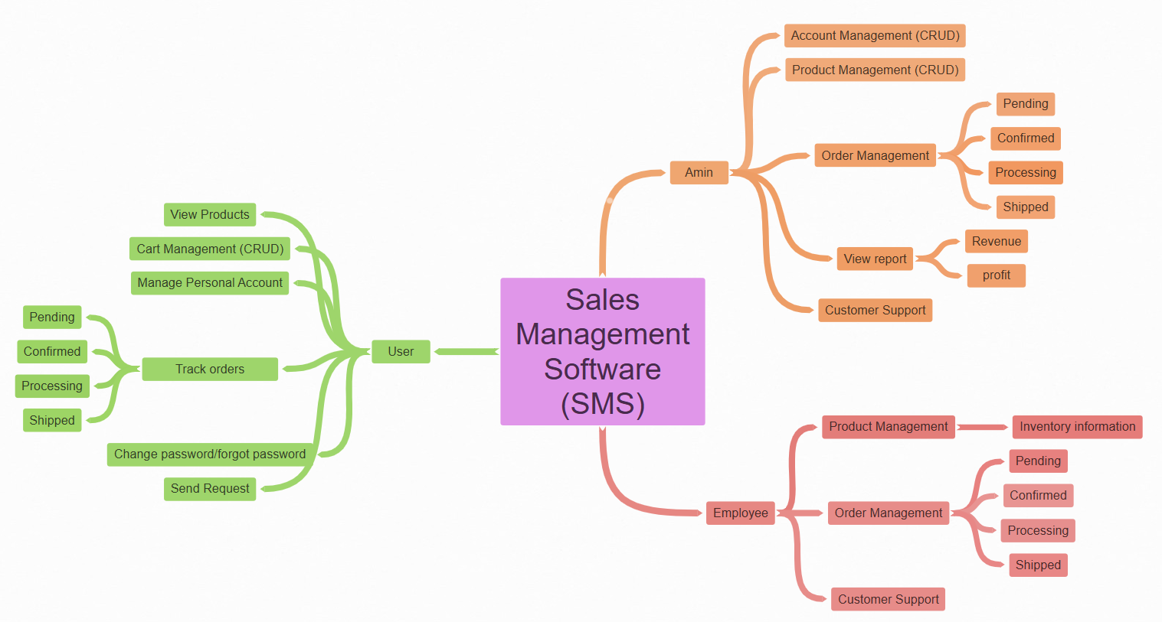

### 6.2 Limitations & Exclusions

LI-1: User has very limited permissions, mainly focused on actions related to their own account and orders.

LI-2: Employee plays a supporting role but still has many restrictions, especially in managing accounts and viewing reports.

LI-2: Admin has the broadest permissions but should be monitored to prevent misuse of authority in non-relevant tasks.